Mechanic Planning: Level Design (Parkour & Puzzles)

Concept Overview
I want to structure a 2D level that is both challenging and fair. Showing off mechanics is always fun until the player just jumps over the platform you wanted them to land on. This is why I think I should introduce more dynamic hazards to the levels, specifically Falling Traps and potentially Proximity Bombs. These will add tension and require the player to be more observant. I also want to add disappearing platforms which could use a similar state system to toggle their colliders on and off over time. I think these things will be good because unlike a tricky jump which unexpectedly becomes avoidable due to poor level design, these mechanics should be much harder to “cheese.”

Implementation Strategy
To manage these efficiently, I will use the State Pattern again. A proximity bomb or a spike trap could have "Armed", "Disarmed", and "Firing/Falling" states. This is similar to how I manage the player. Instead of a lot of Boolean checks, the trap will check its state in Update or FixedUpdate.
- Armed: Checks for player presence. If found, trigger and switch to Disarmed/Reloading.
- Reloading: Wait for a timer, then switch back to Armed.
- Disarmed: Do nothing.

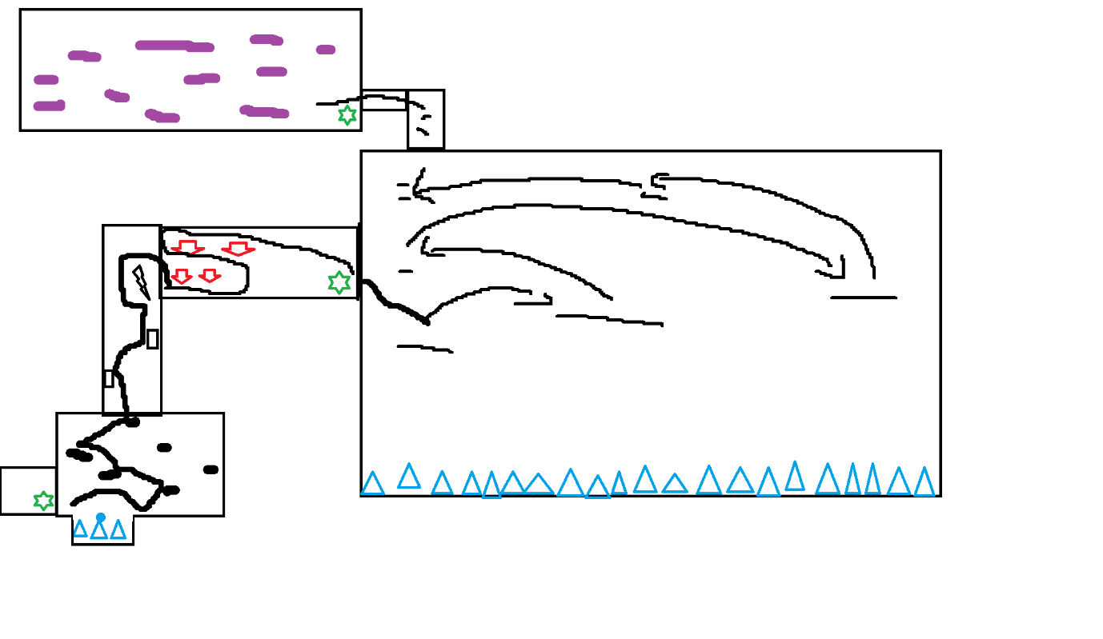
Design Goals
-Door
-Basic Spike
-Falling Spike
-Corner for testing head bump correction
-Semi-solid platform

My goals for the levels will be a mix of "Parkour" (skill-based movement) and "Puzzles" (logic-based interaction).
- Phase 1: Teach the Forgiveness Mechanics: The first levels will be a "safe" environment to teach the core mechanics.
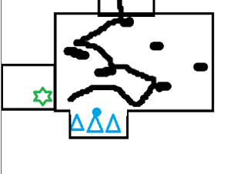
  - Level 1 (Jumping): Wide platforms to teach Variable Jump Height. The gaps will be just too far, forcing the player to learn to hold the button.
  - Level 2 (Forgiveness): A series of small platforms that seem to require perfect timing. This will secretly teach Coyote Time and Jump Buffering, as players will succeed even if their timing is sloppy.
  - Level 3 (Apex): A long-distance jump over a SpikeTrap that looks impossible, but the Apex Hangtime gives the player the extra "float" to clear it. I may show this off earlier on so they can use it more later.
- Phase 2: Combine and Test (Parkour): Later levels will be "gauntlets" that combine these mechanics.
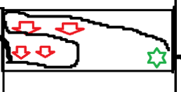
  - A "Spike Gauntlet" will require precise use of Apex Hangtime to clear obstacles.
  - A "Vertical Maze" will use the drop spikes to surprise the player.

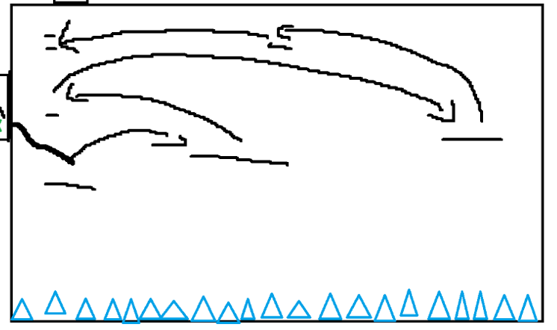

  - The Warp Dash mechanic will be introduced to cross "impossible" gaps, all at longer and longer distances over a massive spike pit. If the player can make the hardest one, the last is easier.
- Phase 3: Puzzle & Progression:
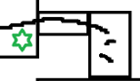
  - The IInteractible system gates progression. A parkour challenge will lead to a Lever, which opens a Door, which reveals the next parkour challenge.
  - This creates a "Parkour-Puzzle" loop, which is a staple of the genre.
- Phase 4: (Showcase):
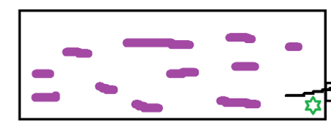
  - This will be the final room which acts as sort of an overflow area for anything I could not fit into the rest of the level. It will probably display several things like jump buffering/semi-solids, etcetera.

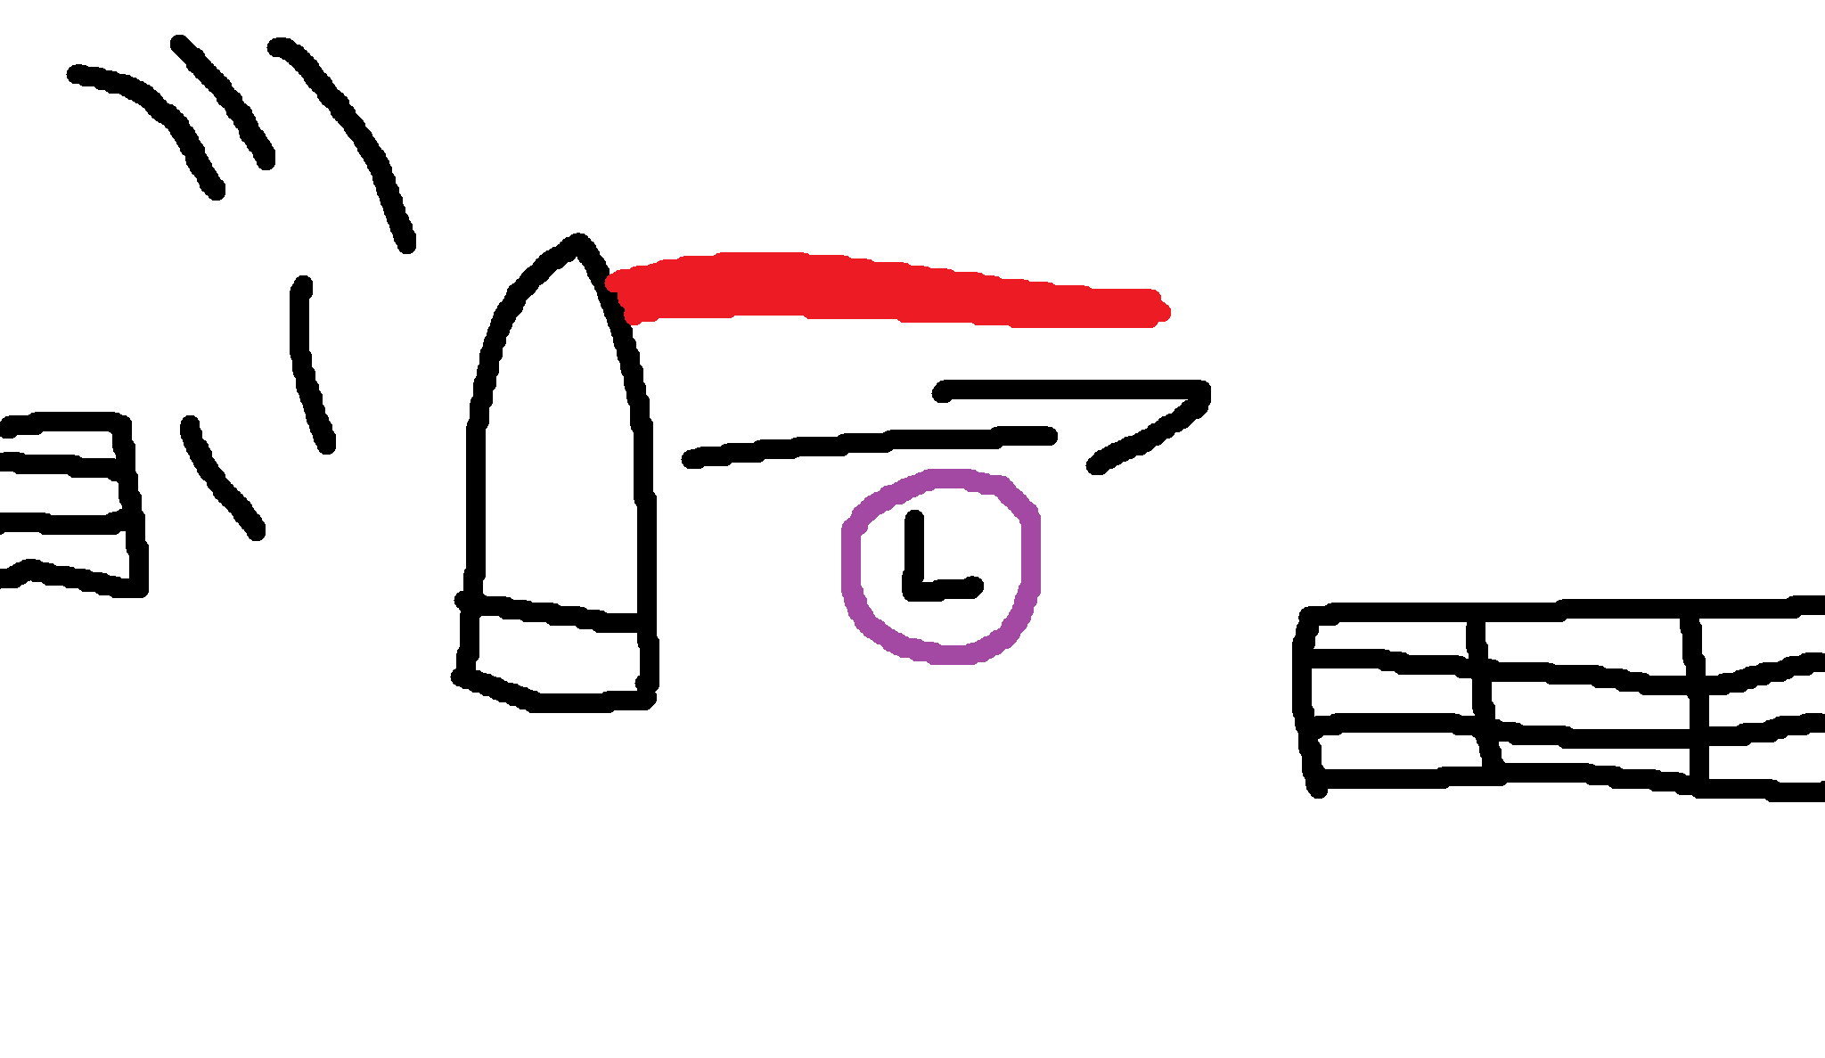
Dash Mechanic

This is the “Time Slowed Dash” mechanic. It works by temporarily slowing down time when the player holds right mouse button. The player then shoots a red laser out of their head. You cannot jump when you are in this “Aim” state. When the right mouse button is released, the laser will be deactivated, time will return to normal speed and the player will then dash in the direction of the laser. When the player lands friction is applied for 0.2 seconds, before all friction returns to normal.
Values Tweaked
Value | Start | End
m_DashForce | 25 | 20
m_DashDuration | 0.25 | 0.4
m_DashCooldownTime | 0.2 | 1.25
m_MovementLockDuration | 0.5 | 0.5
m_PostDashFriction | 0.25 | 0.15
m_SlowMoScale | 0.25 | 0.25

The cooldown was increased because one section was found to be far too easy after testing. The duration was increases so the player had friction applied at the correct time and friction was increased (lower value = higher friction due to method of application) because the player was sliding too far after a horizontal dash.

Screen Enlarge Mechanic
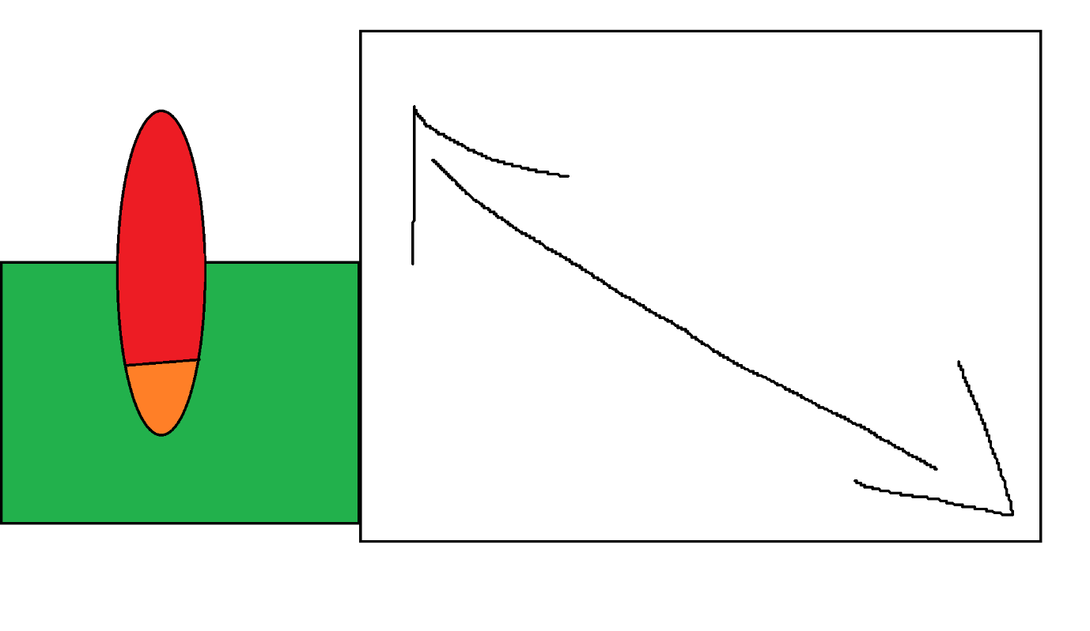
Detection Zone
Player
This was relatively easy to implement. I just imported the Cinemachine plugin and added a new camera (each with varying lens sizes) for everyone. I then put a script on a box collider object which changed the camera priority of the referenced camera to 5 higher than that of the new Cinemachine camera following the player. After that it was just a case of making it a prefab to put in every room, apply all of the individual camera references, etc. Then I had to get the main camera to work with the new Cinemachine brain which was a pain due to the update type being wrong. In the end, I had to put it on LateUpdate() and interpolated the player (in the RigidBody component), so they were smooth. I also added a pixel perfect camera component to the player Cinemachine camera and the main camera. Lastly, I customised the player camera dead zone so the camera wasn’t always directly on the player. This gave the gameplay a bit of natural latency and smoothness. The main issue here was the amount of values it gave you to tweak, all which have knock-on effects to other aspects of the system you may not even consider. Now whenever the player enters a new room the camera pans out so you can see the whole thing, until you move off the “doormat” overlap box.

Values I Tweaked
Main Camera Cinemachine Brain
Value | Start | End
Update Method | SmartUpdate() | LateUpdate()
Default Blend | Ease In Ease Out | Ease Out
Ignore Time Scale | False | True

Player Camera
Value | Start | End
Priority | 5 | 10
Lens | 8 | 5
Dead Zone | 0, 0.5 | 0.3, 0.5
Damping | 1, 1, 1 | 0.5, 0.5, 0.5

Ignoring timescale needed to be ignored because of the time warp dash, the camera would not have updated properly had it stayed disabled. The player lens and damping needed to be changed so the camera was a bit wider and responded to player movement a bit faster.

Lever Door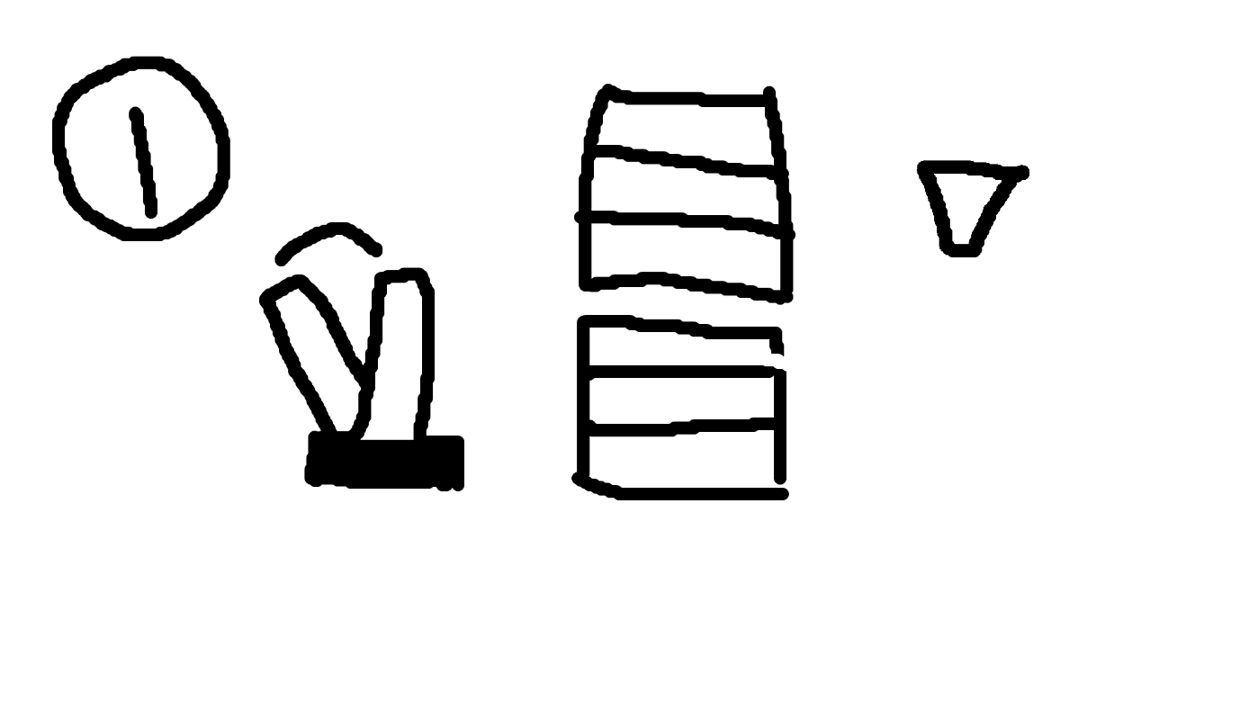
Top door
Toggle angle
Lever
Bottom door
Top door
Light (OFF)
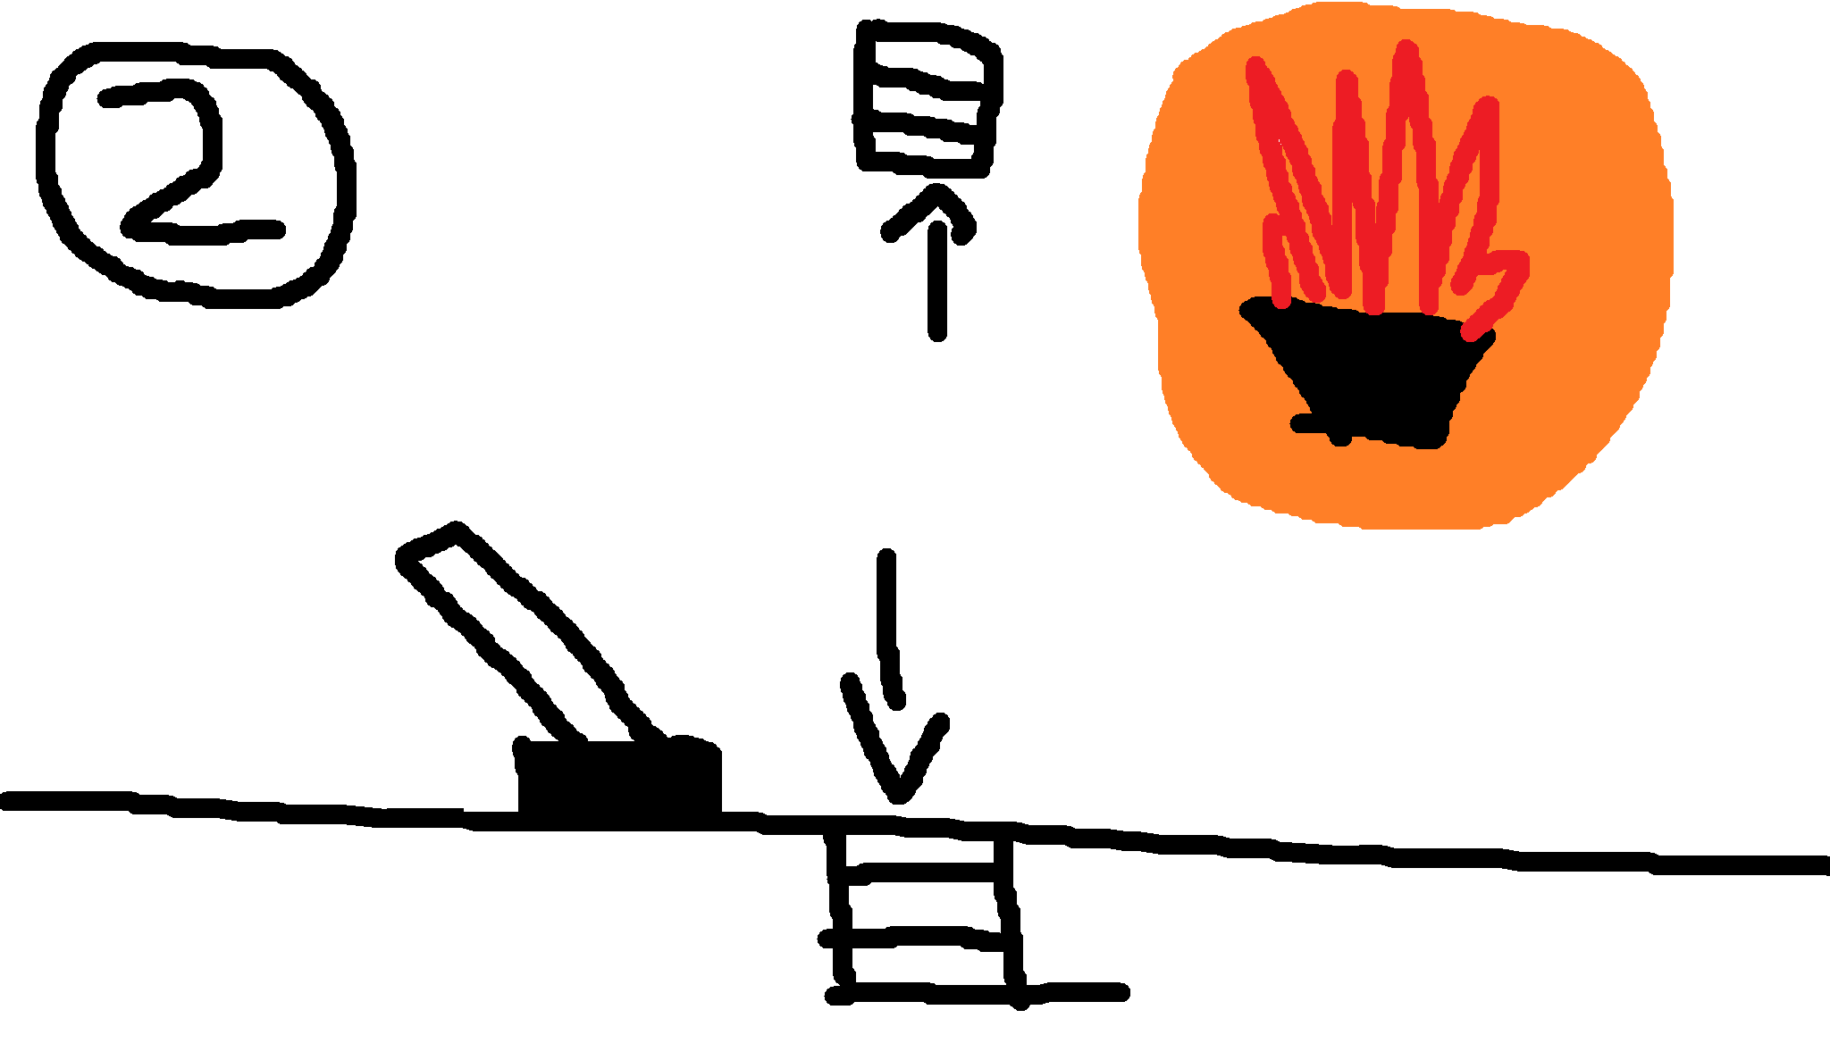
Bottom door
Lever
Light (ON)
This worked by using the Iinteractible interface on the lever object and door object simultaneously. Instead of the door having 2 scripts that needed to run through the interactable interface, I just had the initial circle cast iterate through the first 5 interactable objects instead.
This prevented any issues from occurring where logic in one script is ran before another because of the order of the scripts in the inspector. The lever activates the torch but only works if the doors are fully open or closed because it has a reference to the doors. The door object has an invisible collision box positioned on the lever, so it always gets activated when the lever is activated (unless the lever is moved). When the doors are activated they both use the MoveTowards() function to toggle between the open and closed states.

Values Changed
Value | Start | End
m_MoveDistance | 1 | 1.01
m_MoveSpeed | 1 | 0.6

I increased the move distance slightly so there were no clipping issues with the door poking above the ground slightly when its open. The move speed was changed a lot because originally I had my doors lerp towards each other. This was bad because it meant no matter what speed I put in the doors would always start moving very quickly and would then slow down. Using MoveTowards() is much more consistent.

Falling Spike
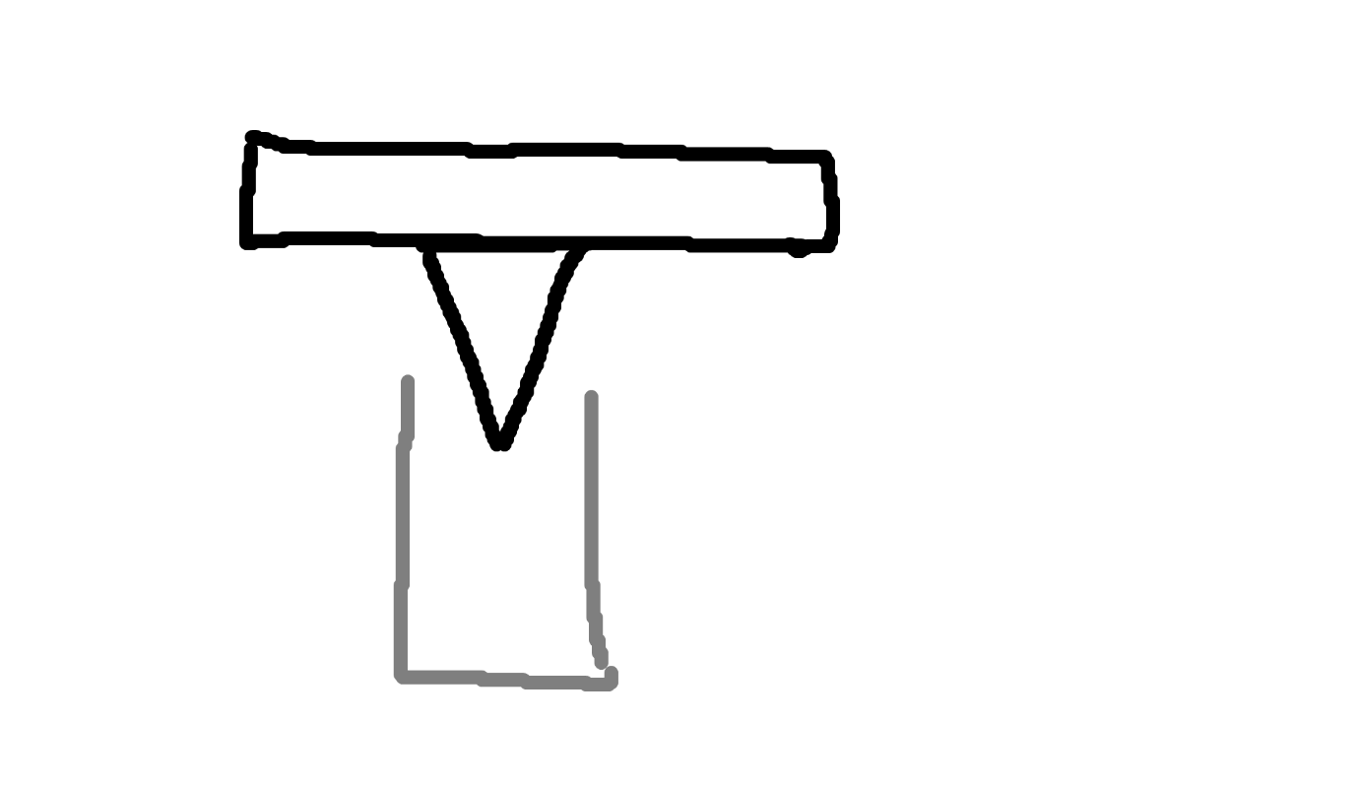
Platform
Spike
Overlap box
This was done by changing the RigidBody physics of the spike to dynamic if the player goes in the detection zone. The spike is made very heavy and is destroyed shortly after hitting the player or upon hitting the ground and having low velocity.
Value | Start | End
m_DestroyDelay | 0.2 | 0.25
Overlap Box Size | 1 | 2
Scale | Even all around | Small and long

I increased the destroy delay so it looked like the spike actually entered the player as opposed to just tapping it and then immediately blinking out of existence. The overlap box also wasn’t large enough to detect the player initially, especially after I scaled the spikes to be smaller and longer.

HUD
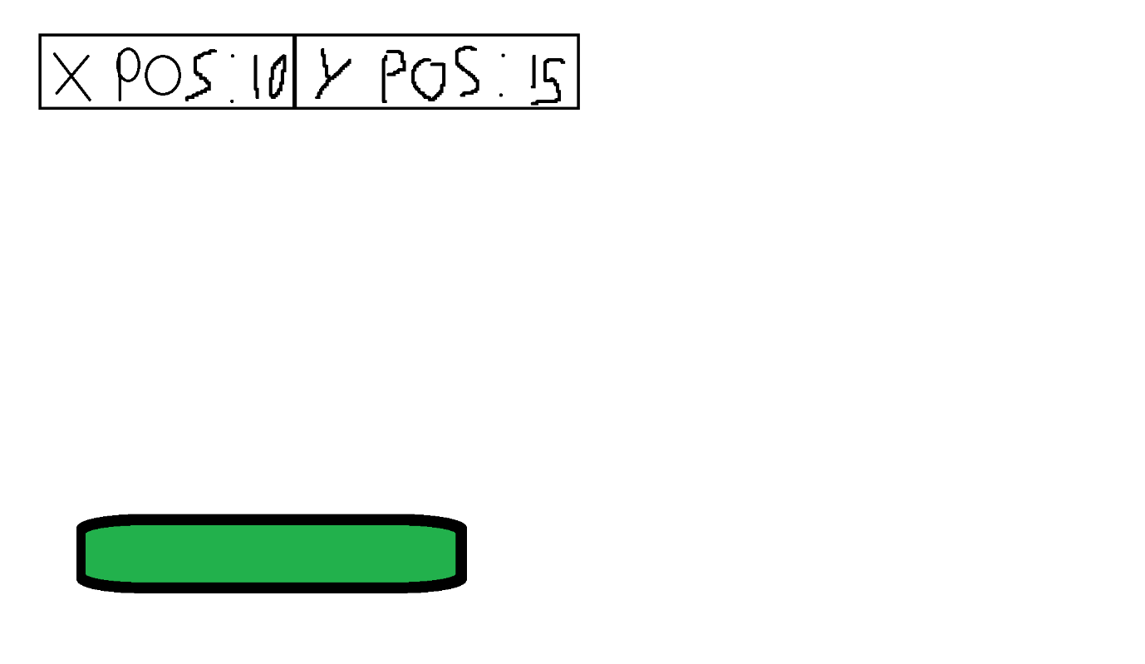
Healthbar

The “X pos” and the “Y pos” display the player’s current position. I also moved the health-bar into the bottom left corner to be more in line with games like Fortnite. This was from originally being in the top left like Elden ring, but t he “X pos” and the “Y pos” variables made it look a bit too congested.

Death HUD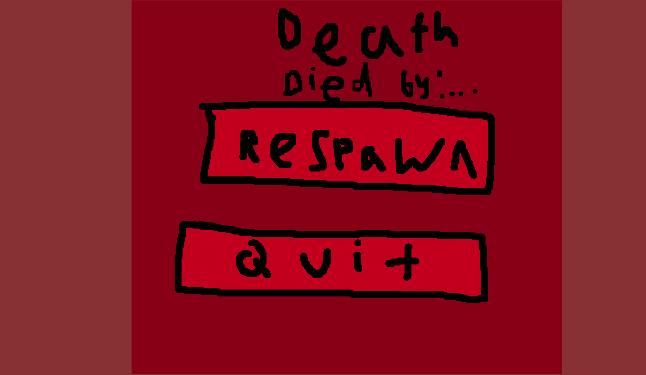
This was heavily inspired by Minecraft’s death screen. The buttons all function the exact same and you the same label telling you what you have been killed by. The two different shades of red are inspired a bit by GTAVs “WASTED” screen, where the background goes darker and blurry. That’s why they are both translucent backgrounds, its to create more contrast and make the death more dramatic because you can still sort of see what killed you.

Final Thoughts
This plan uses the mechanics as the foundation for the level design. The "forgiveness mechanics" (Coyote Time, Buffering, Apex Hang, etcetera) are not just "game feel"; they are teaching tools that allow us to make the actual level design more interesting and difficult. This is because the player will feel the controls are fair. This will require a lot of careful, iterative balancing to ensure the difficulty curve is smooth and fun.

